HANDOUT PACKAGE
Month 1: Getting to Know Your Class
Companion to the “Big Picture: Beyond Individual Lesson Planning” PD session
Worksheets compiled in the order they are used in class

Contents
Worksheets appear below in the order they are used in the first month of class.
Section | Worksheet | Used
1. Autobiography | Beginner Level | Week 1
1. Autobiography | Beginner–Intermediate Level | Week 1
1. Autobiography | Advanced Level | Week 1
2. Needs Assessment | Pictorial Needs Assessment | Week 2–3
2. Needs Assessment | Theme / Topic Choice Worksheet | Week 2–3
3. Goal Setting | Setting Goals — Video Listening Worksheet | Week 3
3. Goal Setting | Goal Setting Worksheet — Version 1 | Week 4
3. Goal Setting | Goal Setting Worksheet — Version 2 | Week 4
4. Self-Reflection | What I Learned This Month | End of module

Note: pick ONE autobiography level per class, and either version of the Goal Setting worksheet — both versions are included so you can choose the one that best fits your learners.

Autobiography — Beginner Level
Section 1 — Autobiography · Choose the version that matches your class level. Use after Week 1 icebreakers, before pair-work interviews.
Name: ______________________________ Date: _______________

My Autobiography
Fill in the blanks.
My name is ______________________. I was born in ______________________.
One of my favorite memories from my childhood is
I have _____ brothers and _____ sisters. Their names are
One thing I miss from my country is
My favorite color is ________________. My favorite food is ________________.
My favorite hobby is ________________. I am married / single.
I came to Canada in ______________. My favorite thing about Canada is
Now that I live in Canada, I
In the future I hope to
Draw a picture of yourself or something you like.

Autobiography — Beginner–Intermediate Level
Section 1 — Autobiography
Name: ______________________________ Date: _______________

My Autobiography
Finish the sentences about yourself.
My name is ______________________ and I come from ______________________.
I have lived here for _______ years.
I live with my
My favorite season is ________________ because it is ________________.
I like to
I want to learn English because

Autobiography — Advanced Level
Section 1 — Autobiography
Name: ______________________________ Date: _______________

My Autobiography
Write about yourself using complete sentences and paragraph format. Answer these questions:
- Who are you?
- What did you do before you came to Canada?
- What are you doing in Canada right now?
- What do you want to do in Canada in the future?

Pictorial Needs Assessment
Section 2 — Needs Assessment · Individual → small group (3) → whole-class ranking. Use the pictorial version for lower levels or emerging literacy; use the theme worksheet for higher levels.

I Want to Learn English for…
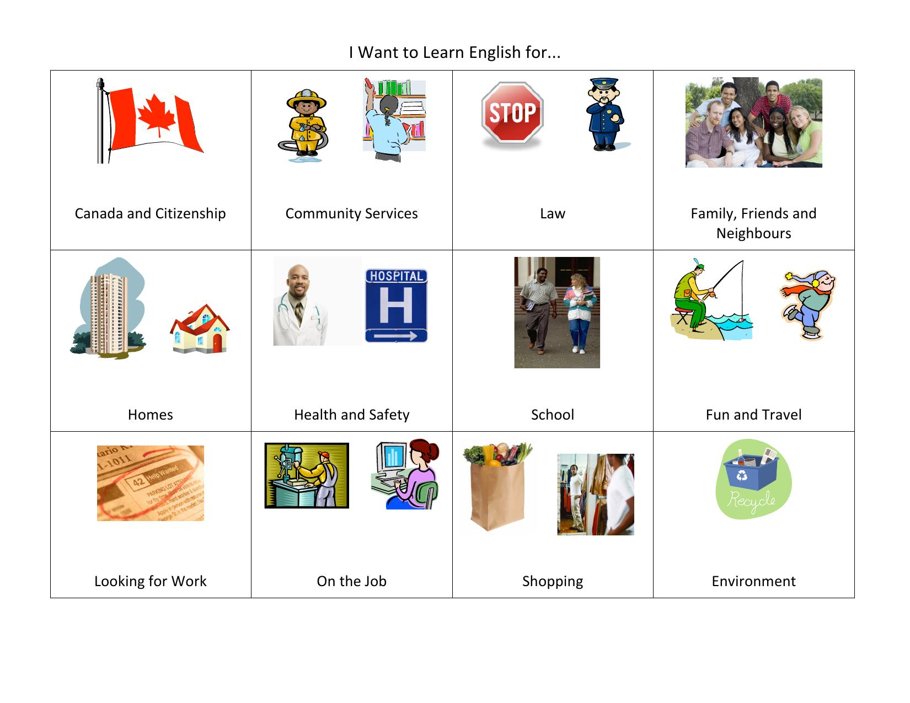
Mark your top priority topic. Then discuss with your group of 3 and agree on your group’s top 3 priorities.

Theme / Topic Choice Worksheet
Section 2 — Needs Assessment

Themes
Choose 3 themes that you are most interested in. Then, in your group, discuss your choices and see if your group can agree on the top 3 themes you are all interested in.
# | Theme | For example
1 | Canada | history, geography, government, citizenship
2 | Canadian Culture | social interaction, cultural differences
3 | Canadian Law | safety at home, can a landlord raise rent
4 | Commercial Services and Business | reading prescription bottles, at the mall
5 | Community and Government Services | at the public library, neighbourhood services
6 | Education | children’s education, a parent-teacher interview
7 | Employment | looking for a job, job application form
8 | Family and Relationships | family responsibilities, family problems
9 | Health and Safety | flu shots, food and nutrition
10 | Travel and Transportation | on the road, dream vacation
11 | Other? | list any other themes you are interested in if they are not on this list

Your Theme Choice
What is your first choice? Why?
What is your second choice?
What is your third choice?

Group Decision
What is your group’s first choice? Why?
What is your group’s second choice?
What is your group’s third choice?

Setting Goals — Video Listening Worksheet
Section 3 — Goal Setting · Teach the SMART goals lesson first; complete the goal-setting worksheet the next class or week.
Video: Setting Goals (YouTube)
Name: ______________________________ Date: _______________

I. Watch the whole video and answer the questions.
1. What are the two types of goals you can set for yourself?
2. What do SMART goals stand for?

II. Listen again until 1:46 and put a check mark if you hear the words below:
☐ objective | ☐ encourage | ☐ ambition
☐ sacrifice | ☐ accomplish | ☐ inspiration

Find synonyms or the correct definition for the words in bold.
Objective /əbˈdʒek.tɪv/
a. point b. aim c. subjective d. goal
Accomplish /əˈkɑːm.plɪʃ/
a. achieve b. able c. fail d. fulfill
Ambition /æmˈbɪʃ.ən/
a. plan b. strong desire c. dream d. motivation
Sacrifice /ˈsæk.rə.faɪs/
a. the act of giving up something valuable to you in order to help someone else
b. considered holy and deserving respect, especially because of a connection with a god
c. the act of killing an animal or person and offering them to a god or gods

Setting Goals — Video Listening Worksheet (continued)
Section 3 — Goal Setting

III. Listen from 1:46 and complete the sentences with one word:
a. If your goals are not ______________, you will have no idea when you have achieved them. Know what you want to improve on and focus on it.
b. Measurable goals have three criteria that you can use to ______________ your progress.
c. In order to have an ______________ goal, you need to consider what is possible for you to complete in the timeframe that you have available.
d. For a ______________ goal you will need to consider how much free time you have, how long each activity takes, and your personal abilities.
e. ______________ goals set deadlines that you need to meet in order to accomplish your goal.

IV. True or false
Short term goals:
 | True | False
a) can easily overwhelm you. | ☐ | ☐
b) help you come closer to your long-term goal in small steps. | ☐ | ☐
c) allow you to set an objective to work towards in the long run. | ☐ | ☐
d) makes it harder to approach the whole project. | ☐ | ☐
Using the SMART framework can:
 | True | False
a) Help you succeed in school or work. | ☐ | ☐
b) Increase your knowledge in a specific area. | ☐ | ☐
c) Help you solve problems effectively. | ☐ | ☐
d) Help you create personalized and achievable goals. | ☐ | ☐

Goal Setting Worksheet — Version 1
Section 3 — Goal Setting
Name: ______________________________ Date: _______________

General Goals
Why are you studying English?
What is your main long-term goal in Canada?
(Ex: get a job, go to school, support my family, be active in my community, etc.)

a. | Is this a SPECIFIC goal? Can you make it more specific?
b. | How will you know if you have reached this goal?
c. | Are you ready to start working towards this goal now?
d. | Is it even possible to reach this goal?
e. | How long will it take you to reach this goal?
After you finish this class, what is your next step?

English Goals
In English, I don’t know how to ____________________________________________
Speaking
I want to learn how to speak to ________________________________________________
I want to learn how to talk about ______________________________________________
Listening
I want to learn how to understand ______________________________________________
Reading
I want to learn how to read ___________________________________________________
Writing
I want to learn how to write __________________________________________________
The skill I would like to improve the most during this course is: (Choose ONE)
☐ Speaking ☐ Listening ☐ Reading ☐ Writing
I would also like to improve my: (Choose ONE)
☐ Grammar ☐ Pronunciation ☐ Vocabulary

Goal Setting Worksheet — Version 2
Section 3 — Goal Setting
Name: ______________________________ Date: _______________

General Goals
Why are you studying English?
What is your main long-term goal in Canada?
(Ex: get a job, go to school, support my family, be active in my community, etc.)

a. | Is this a SPECIFIC goal? Can you make it more specific?
b. | How will you know if you have reached this goal?
c. | Are you ready to start working towards this goal now?
d. | Is it even possible to reach this goal?
e. | How long will it take you to reach this goal?

English Goals
Speaking
I want to learn how to speak to ________________________________________________
I want to learn how to talk about ______________________________________________
Listening
I want to learn how to understand ______________________________________________
Reading
I want to learn how to read ___________________________________________________
Writing
I want to learn how to write __________________________________________________
The skill I would like to improve the most during this course is: (Choose ONE)
☐ Speaking ☐ Listening ☐ Reading ☐ Writing
I would also like to improve my: (Choose ONE)
☐ Grammar ☐ Pronunciation ☐ Vocabulary

What I Learned This Month — Part 1: Questions
Section 4 — Self-Reflection · Use at the end of the module, after a review activity (e.g. a Kahoot quiz covering recent lessons).
Name: ______________________________ Date: _______________
With a partner, discuss what you have learned in class this month. Then give your own answer to these questions using complete sentences (write one sentence for each question).
What is the most useful thing you learned how to do this month?
How can you use this outside of class?
What class activity did you like best? Why?
What has improved the most for you this month?
What do you want to learn how to do next month?
My participation in class discussions was:
☐ less than once per week ☐ about 1–2 times per week ☐ more than 2 times per week
My attendance was:
☐ not very good ☐ good ☐ excellent

What I Learned This Month — Part 2: Paragraph
Section 4 — Self-Reflection
Name: ______________________________ Date: _______________
Now combine all your answers together into one paragraph.

